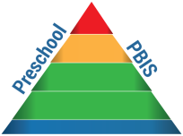
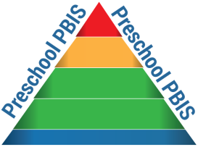
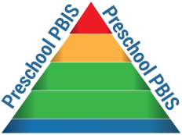
DESERT/ MOUNTAIN SPECIAL EDUCATION LOCAL PLAN AREA
DESERT/MOUNTAIN CHARTER SPECIAL EDUCATION LOCAL PLAN AREA
17800 HIGHWAY 18 • APPLE VALLEY, CA 92307
(760) 552-6700 • (760) 242-5363 FAX

Preschool Positive Behavioral Interventions & Supports (PBIS) Letter of Intent

PROGRAM information
Program: |  |  |  |  |  |  |  | Site:
Street Address: |  |  |  |  |  | City: |  |  |  |  |  | State: |  |  |  | Zip Code:
Program Administrator: |  |  |  |  |  |  | Contact Phone: |  |  |  |  |  |  |  | Fax:
E-mail Address:
section i: mission and desired outcomes
NOTE: The Desert/Mountain SELPA will provide professional development opportunities for programs with a demonstrated need to establish program-wide behavior support and make a program-wide commitment for the implementation of an evidence-based practice. The PBIS training model will increase internal capacity, flexibility, and sustainability of PBIS in preschool programs.
DESIRED OUTCOMES:
- Increase pro-social and emotional behaviors | - Increase time on task | - Increase ability to develop positive relationships
- Establish prevention and early identification | - Create consistent, predictable, positive classroom | - Decrease suspensions, expulsions, and increase
systems as a way of doing business | environments | attendance

section ii: information required
Indicate the areas of concern that the school site would most like PBIS implementation to assist with: (Please check all that apply)
Aggressive/Anti-social Behaviors |  | Attendance Rates | Expulsion Rates | Low Socio-Economic
Partnerships with Families |  | Predictable Environments | School Connectedness | Suspension Rates
Other At-risk Behavior(s):

Provide a brief narrative (at least one paragraph) stating why the program needs PBIS.
section iii: acknowledgements / commitments
SITE COMMITMENTS: The following has been reviewed/completed, and the site agrees to the outlined understandings:
- Team Commitment Form  - Exploration & Adoption Checklist  - Commitment to attend one year of training and ongoing coaching and tier 2 and 3 modules | - To utilize progress monitoring data collection (SWIS) for site-based decision making (behavioral and academic) during the training cycle. (SWIS will be paid for by the Desert/Mountain SELPA during the one year of training)

PROGRAM COMMITMENTS: The program commits to support PBIS in the following areas:
- Support sites in the implementation of PBIS and their sustainability needs
- Participate in PBIS assessments to evaluate the fidelity of implementation of PBIS at the site
- Give the Desert/Mountain SELPA permission to access district and school reports through https://www.pbisapps.org

Site Administrator Signature: |  |  |  |  |  |  |  |  |  |  | Date:
Program Administrator Signature: |  |  |  |  |  |  |  |  |  |  | Date:
PLEASE RETURN FORM TO THE DESERT/MOUNTAIN SELPA, 17800 HIGHWAY 18, APPLE VALLEY, CA 92307, ATTENTION: PBIS TECHNICIAN OR CONTACT (760) 955-3571 FOR ASSISTANCE.

